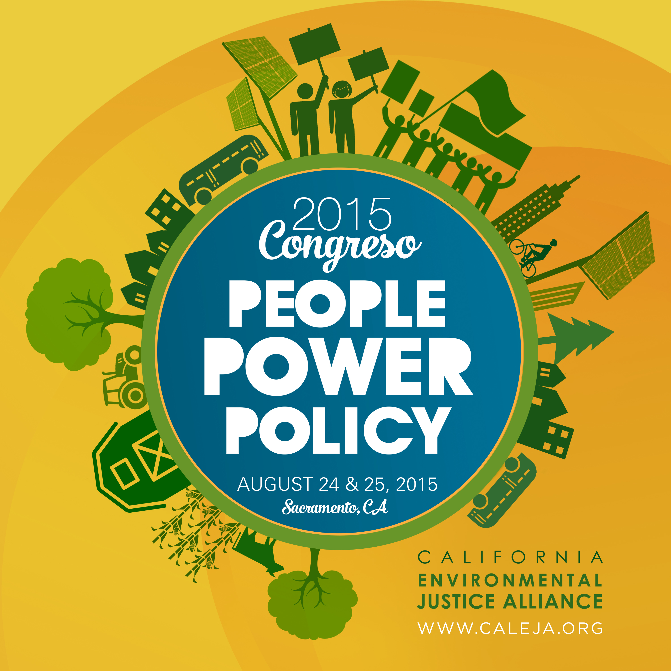
2015 Congreso
“People, Power, Policy”
August 24-25th, 2015
Sacramento, CA

Scholarship Application

Name:
Organization:
Email:
Phone:
Organizational Budget:

Please answer the following questions – you can answer in separate document if needed:

1. Please briefly describe your organization’s mission.

2. Please describe why your organization will benefit from attending the 2015 Congreso.

3. Does your organization represent an environmental justice community? Have you previously or are you currently working on an environmental justice issue?

- Are you currently working with a CEJA Organization?

