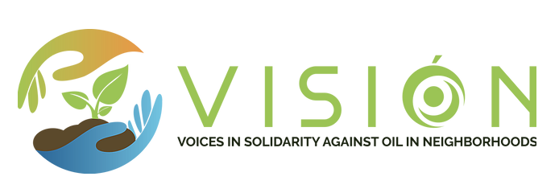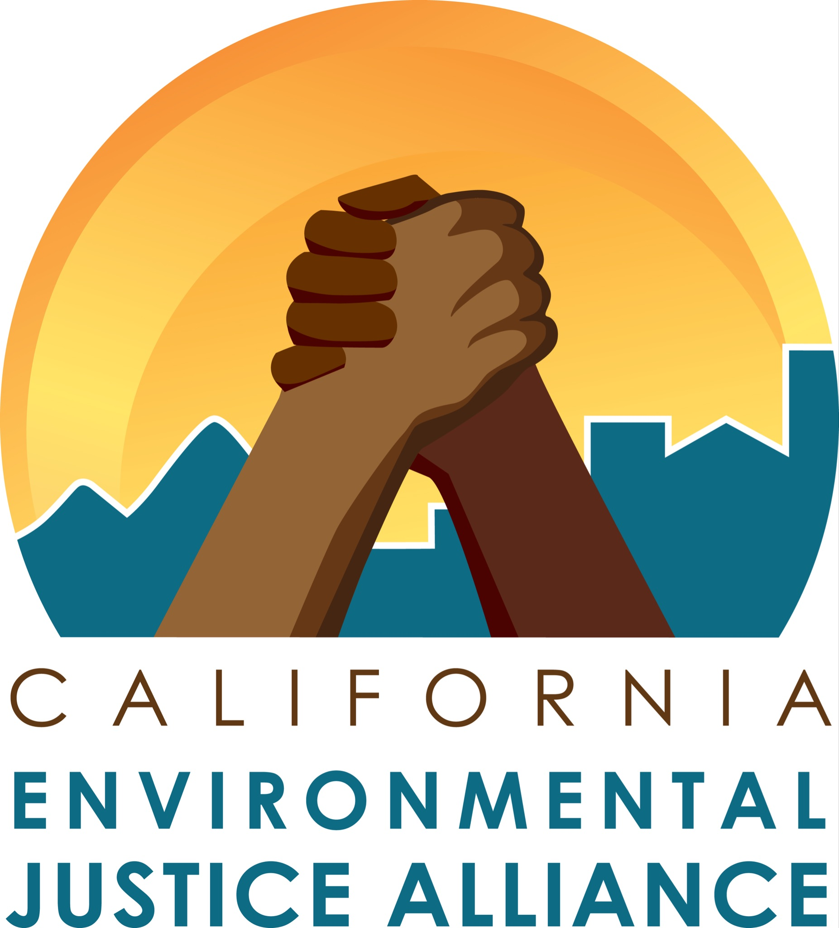

For Immediate Release: October 7, 2021
Contact: Isa Flores-Jones, 916-266-1464
Kobi Naseck, 214) 609-2439‬

Environmental Justice Advocates Respond to OC Oil Spill: Time to end Dangerous Drilling In Our Backyards

(SACRAMENTO, CA) - On Thursday, the California Environmental Justice Alliance (CEJA) and Voices in Solidarity against Oil in Neighborhoods (VISIÓN) urged lawmakers and the Newsom administration to treat the environmental health crisis caused by fossil fuels impacting working communities of color with the same urgency as the Governor’s response to this weekend’s oil spill that occurred off the coast of southern California.

Since 2019, Governor Newsom’s state oil and gas regulatory agency has issued over 9,000 onshore drilling permits while state lawmakers have repeatedly killed legislation that would have directly protected frontline communities from serious adverse health effects from. oil and gas drilling next to homes, schools, prisons, and healthcare facilities.

In the wake of another disastrous oil spill, CEJA and VISION provided the following statement:

“Saturday’s oil spill devastated the natural environment and will continue to destroy local ecosystems. As an alliance of predominantly low-income and Black, Indigenous, and people of color (BIPOC) living in some of the most polluted regions of California, we mourn this extreme poisoning of water and land as yet another example of the exploitation and failings of the fossil fuel industry,” said Tiffany Eng with the California Environmental Justice Alliance.

“Our legislature has failed to protect Californians from the egregious harms of fossil fuel operations through inaction and delay tactics. Oil and gas pipelines, oil fields, and refineries are inherently dangerous neighbors that are incompatible with safe communities,” Juan Flores with the Center on Race, Poverty and the Environment. “Childhood asthma and cancer rates climb, life-expectancies drop, and still our leaders give fossil fuel companies opportunities to line their pockets at the expense of human life. As we condemn this weekend’s oil spill and its impacts on local residents, we urge decision-makers to immediately end offshore and neighborhood drilling, followed by a swift phaseout of remaining oil and gas operations across the state.”

“Air pollution from neighborhood drilling is a chronic, invisible contamination on par with the catastrophe of an oil spill,but one that has continued for decades,” said Cesar Aguirre with the Central California Environmental Justice Network. “High cancer rates and respiratory and neurological diseases spill out from neighborhood oil fields every day, poisoning the people living, working, and going to school just feet away from oil and gas extraction sites.”

“California may be the “tent pole” of environmentalism as our Governor reminded us on Tuesday, but we are also the state with the highest percentage of Black, Indigenous, Latinx, Asian, and Pacific Islander communities living in dangerous proximity to hazardous sites. Nearly 7 million people, the majority BIPOC, live within a mile of oil and gas drilling sites. Of the 2 million Californians living within 2,500 feet of an oil and gas well, 92% are BIPOC,” said Bahram Fazeli with Communities for a Better Environment. “It’s time to enact commonsense setbacks between homes and fossil fuel operations and end neighborhood drilling.”

"Oil spills are an “externality” of the oil industry at the cost of human life and our ecosystem. Refineries regularly flare poisonous emissions and sometimes explode; oil seeps in residential areas as pipes burst or leak; and deadly hydrofluoric acid is used next to homes," said Gladys Limon with the California Environmental Justice Alliance. "Decision-makers have for too long normalized sacrificing the health of Black, Indigenous and people of color (BIPOC) on the frontlines of the fossil fuel industry. Communities and youth are demanding transformative action and real leadership from decision-makers to protect their lives and futures. And while the Governor has moved the ball forward, too many legislators have held it back. Legislators must decide: will they continue to protect the fossil fuel industry or protect the people they were elected to serve?"

“As environmental justice organizations await a decision from CalGEM, the state oil and gas regulatory agency, that could move oil and gas wells away from neighborhoods, we hope that decision-makers will respond to Saturday’s tragedy with bold, urgent action to protect frontline communities across the state,” said Kobi Naseck with VISIÓN (Voices in Solidarity Against Oil in Neighborhoods).

# # #

